Adult Income Classification
Week 1 Final Project Report
1. Problem Definition
The aim of this project was to develop a machine learning classification model that predicts whether a person's annual income is above $50K or below/equal to $50K. The project uses demographic, education, employment, and financial information to make these predictions. Income classification is useful for understanding patterns related to income levels and supporting data-driven analysis. The project followed a complete machine learning workflow, including data preparation, feature engineering, model development, hyperparameter tuning, diagnostics, final evaluation, interpretation, and inference.
2. Data Preparation
The Adult Income dataset was used for this project. The target variable was divided into two classes: 0 = Income ≤ $50K and 1 = Income > $50K. Numerical features were processed using median imputation and StandardScaler. Categorical features were processed using most-frequent imputation and OneHotEncoder. Feature engineering included age groups, working-hours groups, a capital-gain indicator, log-transformed capital gain, a higher-education indicator, and an education-hours interaction feature. A 5-fold Stratified K-Fold cross-validation strategy was used to maintain class distribution during validation.
3. Model Development
Three machine learning models were tested: Logistic Regression, Random Forest, and Gradient Boosting. The models were implemented using pipelines containing feature engineering, preprocessing, and the model. This provided a consistent and reproducible workflow. Gradient Boosting was selected as the final model after model comparison and tuning.
4. Model Tuning
Gradient Boosting was tuned using GridSearchCV with 5-fold cross-validation. The search tested learning rates of 0.01 and 0.1, numbers of estimators of 100 and 200, and maximum depths of 3 and 5. The selected configuration was learning rate = 0.1, number of estimators = 200, and maximum depth = 5. A classification threshold of 0.3 was selected to improve identification of the positive income class.
5. Diagnostics
Learning curves were used to examine training and validation performance and assess the model's learning behavior. The training score decreased as the training data increased, while the validation score gradually improved. The gap between training and validation performance became smaller with more data. This indicates that the model benefits from additional training data and does not show severe overfitting.
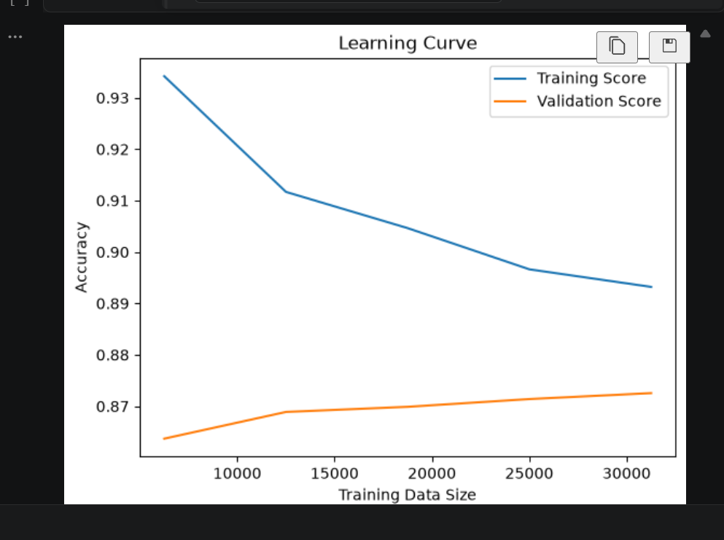
Learning Curve Analysis: The training score starts higher and gradually decreases, while the validation score increases as more training data is used. The decreasing gap between the two curves suggests improved generalization with more data and no severe overfitting.
Calibration analysis was also performed to evaluate the quality of predicted probabilities. The final model achieved a Brier Score of 0.0870, showing useful probabilistic performance.
Calibration curve: insert the calibration plot from the Day 4 notebook here.
6. Final Results
The final Gradient Boosting model was evaluated on unseen test data using the selected classification threshold of 0.3.
Metric | Result
Accuracy | 85.58%
Precision | 66.15%
Recall | 81.39%
F1 Score | 72.98%
ROC-AUC | 92.91%
PR-AUC | 83.29%
Brier Score | 0.0870

Confusion Matrix
 | Predicted ≤50K | Predicted >50K
Actual ≤50K | 6457 (TN) | 974 (FP)
Actual >50K | 435 (FN) | 1903 (TP)
The model produced 974 false positives and 435 false negatives. The lower classification threshold helped the model identify more positive cases, resulting in relatively high recall.
7. Model Interpretation
Feature importance was analyzed to understand which features had the greatest influence on the Gradient Boosting model's predictions. The top important features were marital status (Married-civ-spouse), education number, log capital gain, education-hours interaction, capital gain, capital loss, age, final weight, occupation (Exec-managerial), and occupation (Other-service). These results show that education, capital-related features, age, occupation, and marital status played important roles in the model's predictions.
Feature importance visualization: insert the feature-importance graph from the notebook here.
8. Production Readiness
The final trained model was saved as final_model.pkl, allowing it to be reused without retraining. The preprocessing and model were combined into a single pipeline so that the same feature engineering and preprocessing steps are applied during inference. A working inference example was tested using five unseen examples, producing the predictions 00010. The recorded environment information was Python 3.12.10, Pandas 3.0.5, NumPy 2.5.2, Scikit-learn 1.9.0, and Joblib 1.6.0.
9. Limitations & Future Improvements
The model could be improved with more training data, additional meaningful features, more extensive hyperparameter tuning, and testing of additional algorithms. Future work could also include testing different classification thresholds, improving probability calibration, evaluating performance across important demographic subgroups, investigating false positives and false negatives, and using additional validation techniques. Overall, the project completed a full machine learning workflow from data preparation and feature engineering to model tuning, evaluation, interpretation, and inference.

